Chapter 2, Problem 13.

For the circuit in Fig. 2.77, use KCL to find the branch currents I₁ to I₄.

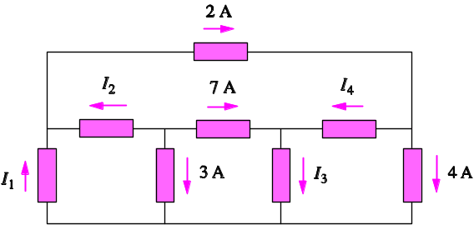

Figure 2.77
For Prob. 2.13.

